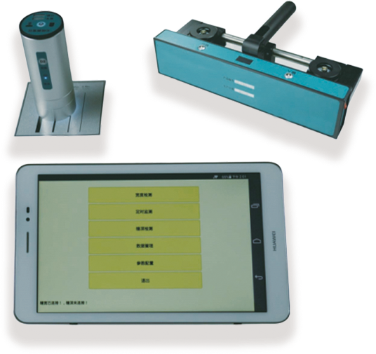
F800 Wireless crack meter
USAGE OVERVIEW
It is used for automatic measurement of crack width and crack depth on structure surface, automatic interpretation and storage of data.

PRODUCT FEATURES
1.New upgraded wireless cloud transmission function;
2.Original wireless camera probe, snap button operation is convenient; host adopts Android system tablet computer, Chinese full touch operation;
3.Intelligent interpretation of oblique cracks, without vertical; images can be zoomed in and out, and the interface display scale can be manually assisted to interpret;
4.The sounding bracket does not need to be crossed, saving time and effort; tablet computer and TF card storage, large capacity without limit, copying data is convenient and fast;
5.The data analysis and report form is included in the main unit, which can be owned without transferring to the host computer.

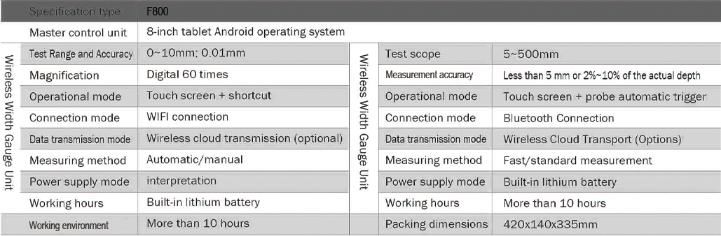
TECHNICAL PARAMETERS

