GTJ-LQ50 Falling ball rebound modulus tester
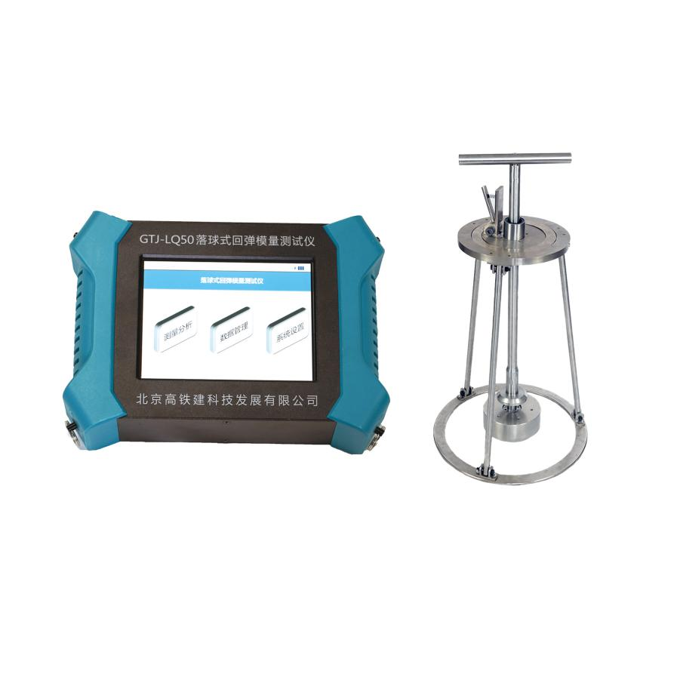

Usage
The principle of the falling ball rebound modulus tester is to raise the rigid sphere to a certain height (50 cm), let the rigid sphere fall freely and collide with the materials along the way, test the acceleration during the process and analyze the acceleration during the impact process. In order to find out the various indicators of earthy materials.
Features
1. The instrument is convenient and quick to operate. Starting from the needs of engineering inspection, users can quickly grasp the use method;
2, small size, light weight, easy to carry;
3. The user operates through the touch screen, and the interface is simple;
4. Large-capacity data memory, support for mobile storage;
5, built-in rechargeable lithium battery, long standby time;
Technical Parameter
Product Model | GTJ-LQ50
System noise voltage | ＜2mV
Dynamic range | ＞138dB
Amplifier band | 10Hz~10kHz
A/D resolution | 16-bit A/D
Sampling time interval | 2us~32768us
Sampling length | 1024, 2048, 4096
Time indication error | ＜1%
Number of channels | 1
Magnification | 1~128
Trigger method | Signal trigger
Sensor sensitivity | 100mV/g
Sensor band | 1-10000Hz
Continuous working time | More than 10 hours
Powder supply | Built-in rechargeable lithium battery（+7.4V）
Weight | 1.24Kg
Size | 220*160*50mm
Display | Capacitive screen 640*480
Operation method | Touch

